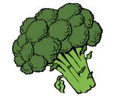

Community Partnership Mass Food Distribution
Come receive food, fresh fruits and vegetables, and other items

August 31, 2020, 10:00 AM
While supplies last!
Columbia County Fairgrounds
182 Hudson Ave, Chatham, NY
- Please do not arrive before 10:00 AM
- Arriving early will cause traffic and crowding
- Food will be given out beginning at 10:00 AM
- If you are driving, stay in your car
- If you are walking, please practice social distancing
- Wear a mask
- Adhering to these instructions will allow us to
distribute food in a quick and timely fashion

Part of Catholic Charities Mobile Outreach Vehicle Extension
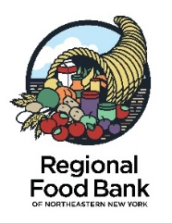
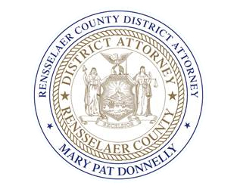
(CC MOVE)

